

**Senchola Batch 3 Applicants Details Analysis using SQL**

1. Created Database **batch3_applicants** by the help of **creating schema** and importing the csv into that database. Table name is createdas **batch3** and now checking the data.

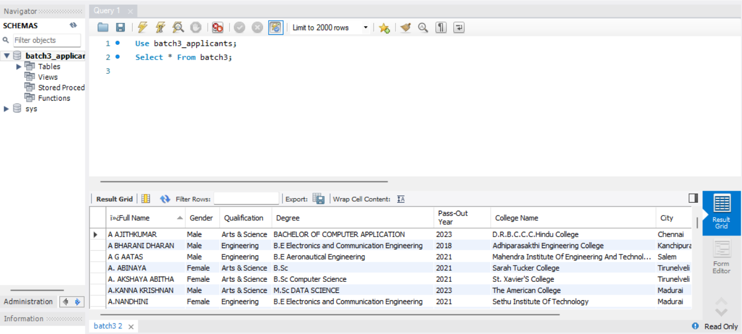

1. Total rows in this table **batch3** are **1269** rows.

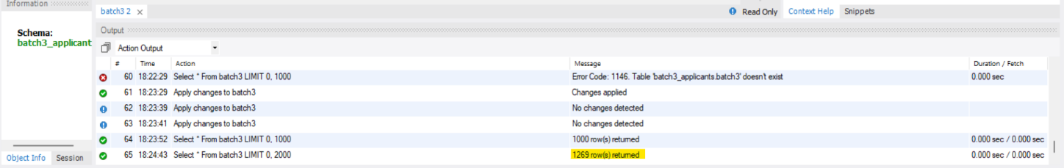

**NOW STARTING THE DATA ANALYSIS BY WRITING QUERIES**

1. **Total number of Applicants:**

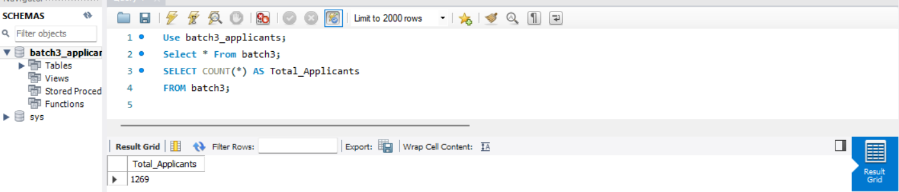

**Total Applicants are 1269.**

1. **Gender Distribution:**

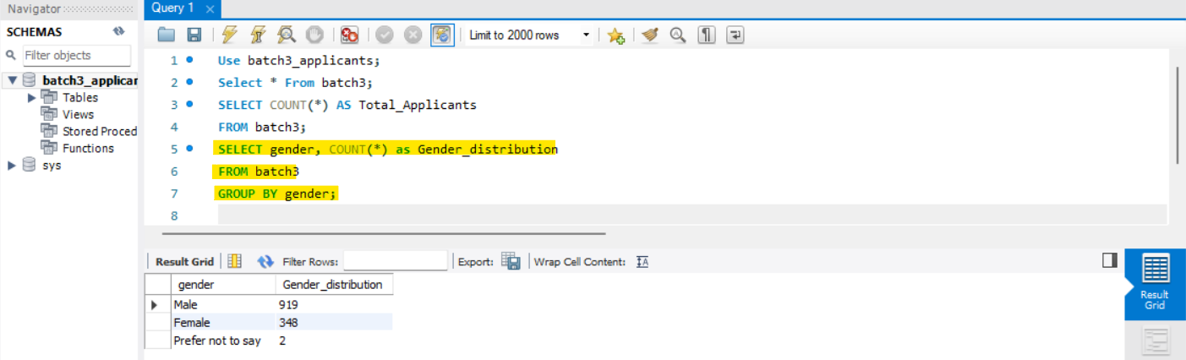

**Male are 919, Female are 348 and prefer not to say 2.**

1. **Educational Background:**

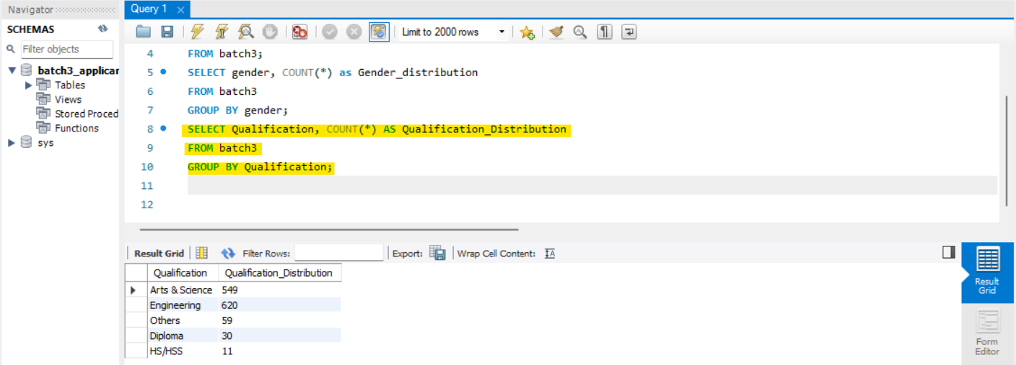

**Engineering is 620, Arts & Science is 549, Others are 30 and HS/HSS is 11.**

1. **Degree Distribution:**

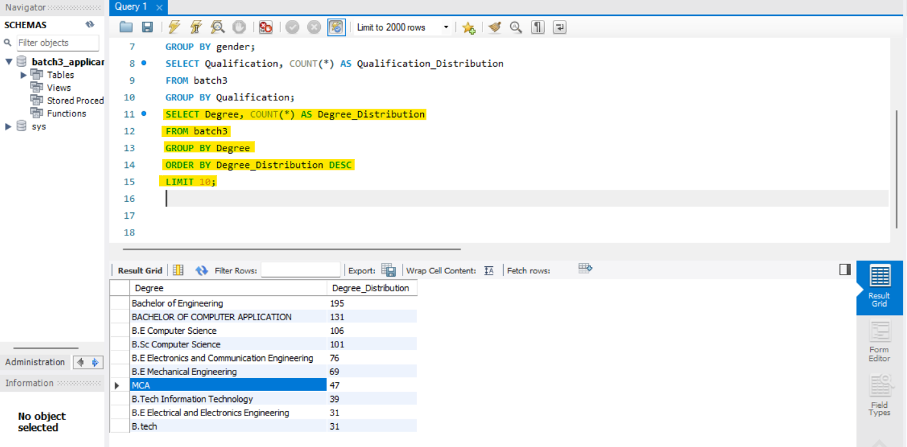

**Bachelor of Engineering tops by 195, Bachelor of Computer Application by 131, B.E Computer Science by 106, B.Sc. Computer Science by 101, B.E ECE by 76, B.E Mech by 69, MCA by 47, B.Tech IT by 39, B.E EEE by 31 and B.Tech 31.**

1. **Pass-out Year Distribution:**

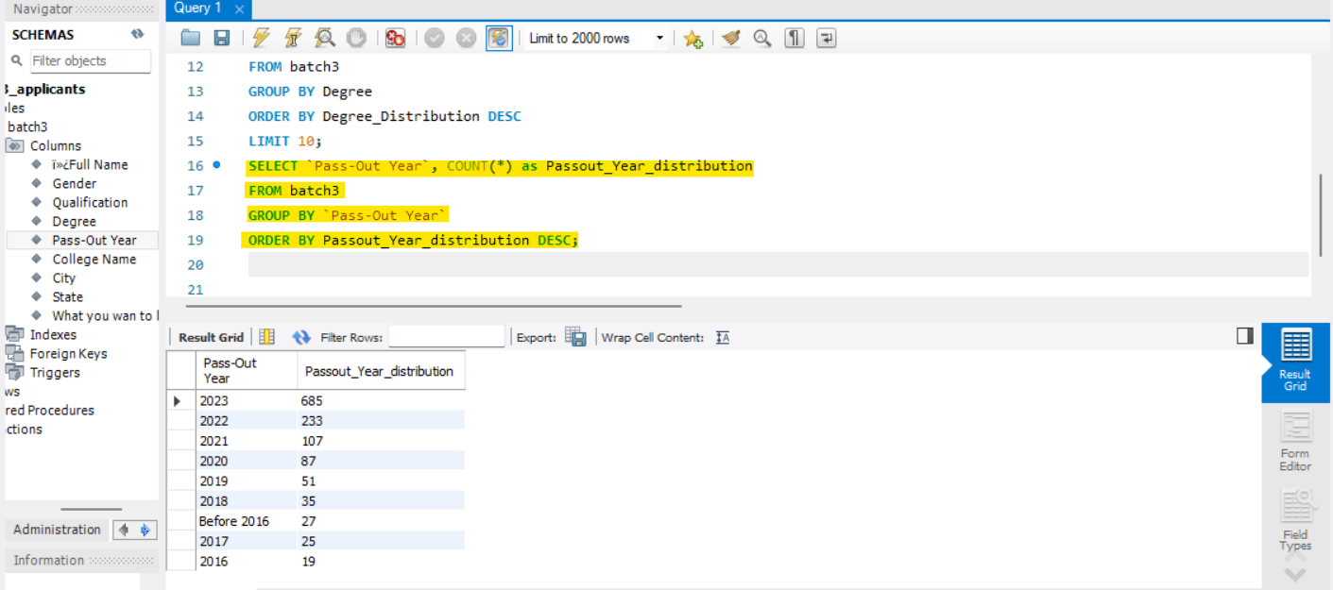

**Applicant’s major passed out in the year is 2023 by 685, followed by 2022 is 233, 2021 by 107,2020 by 87 and goes on…**

1. **College Distribution:**

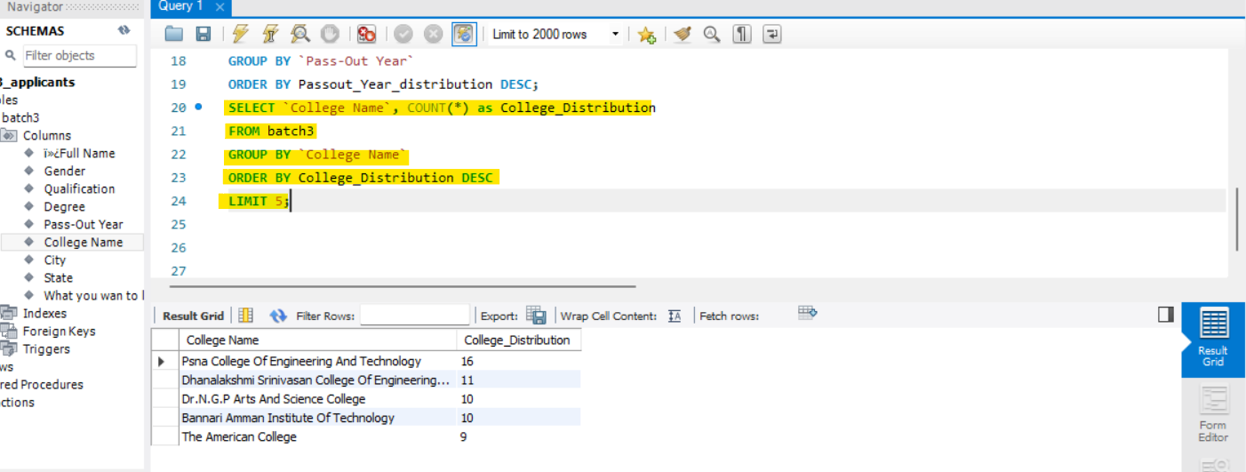

**PSNA College of Engineering tops by 16, Dhanalakshmi Srinivasan College by 11, Dr. N.G.P Arts and Science College by 10, Bannari Amman Institute by 10 and The American College by 9.**

1. **Areas of Interest Distribution:**

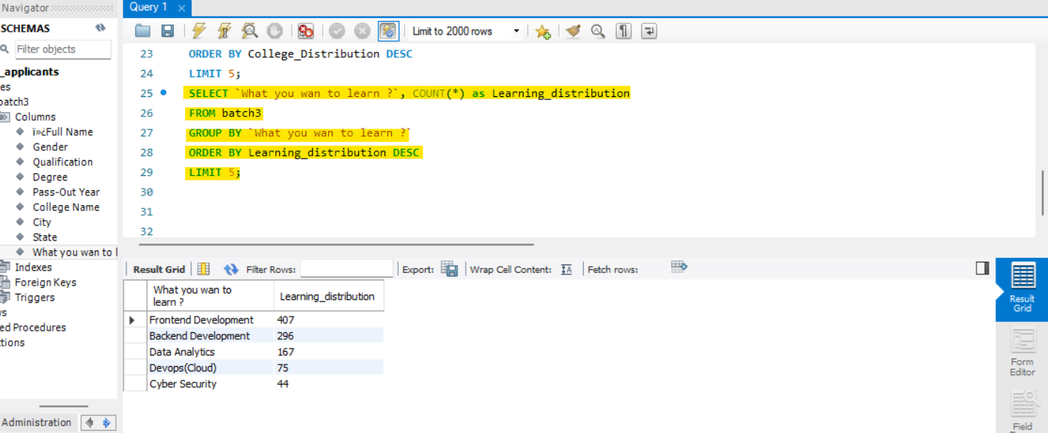

**Frontend Development tops by 407, Backend Development by 296, Data Analytics by 167, Devops by 75 and Cyber Security by 44.**

1. **City Distribution:**

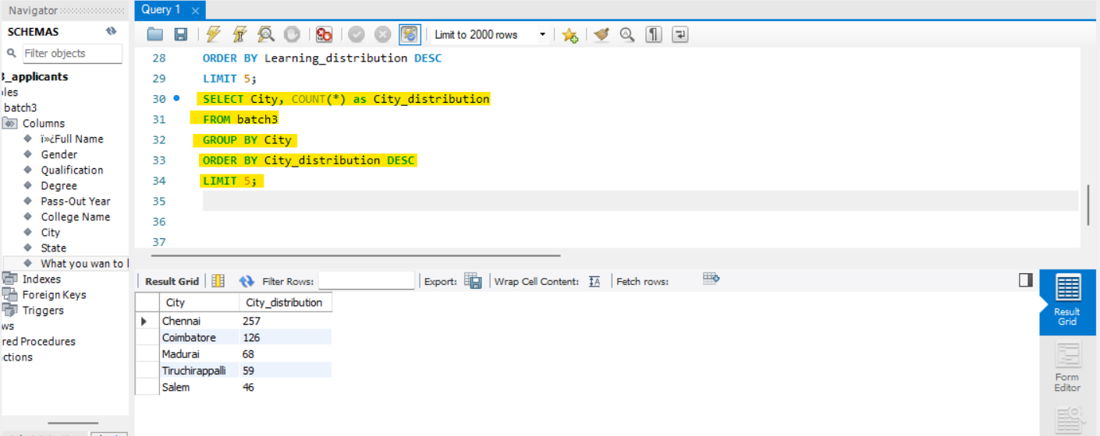

**Chennai tops by 257, Coimbatore by 126, Madrai by 68, Tiruchirappalli by 49 and Salem by 46.**

**So, these are the main insights analysed by querying the dataset. Some recommendations are given below.**

**RECOMMENDATIONS:**

1. **Tailor Communication for Top Qualifications:**
   * With insights into the top qualifications, tailor communication and program offerings to align with the educational backgrounds that are most prevalent among applicants. Highlighting success stories or opportunities related to these qualifications may attract more candidates.
2. **Strengthen Partnerships with Top Colleges:**
   * Given the notable representation from specific colleges, consider strengthening partnerships with these institutions. Collaborate on events, workshops, or internship programs to further engage students and enhance the pipeline of talent.
3. **Diversify Learning Opportunities:**
   * Understanding the areas of interest can inform the development of learning programs. Consider diversifying learning opportunities to cover a broad spectrum of interests, ensuring that the curriculum aligns with the most popular areas of interest.
4. **Regional Targeting in Outreach:**
   * Tailor outreach efforts and events based on geographical locations with a high number of applicants. This could involve organizing more events, webinars, or networking opportunities in these regions.
5. **Consider Industry Trends:**
   * Stay alongside of industry trends and align learning opportunities with emerging technologies or skills in demand. This ensures that the learning programs remain relevant and attractive to the target audience.

**## THANK YOU ##**